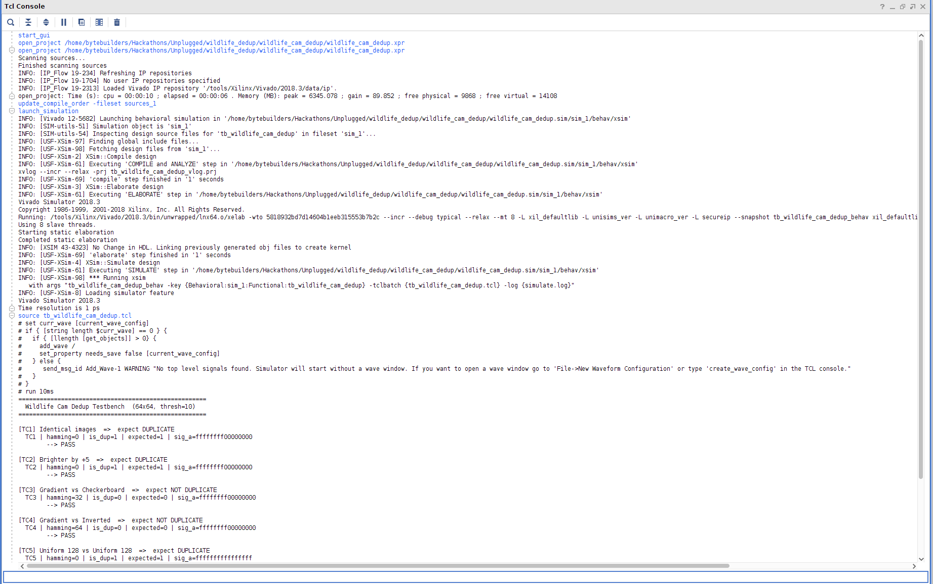

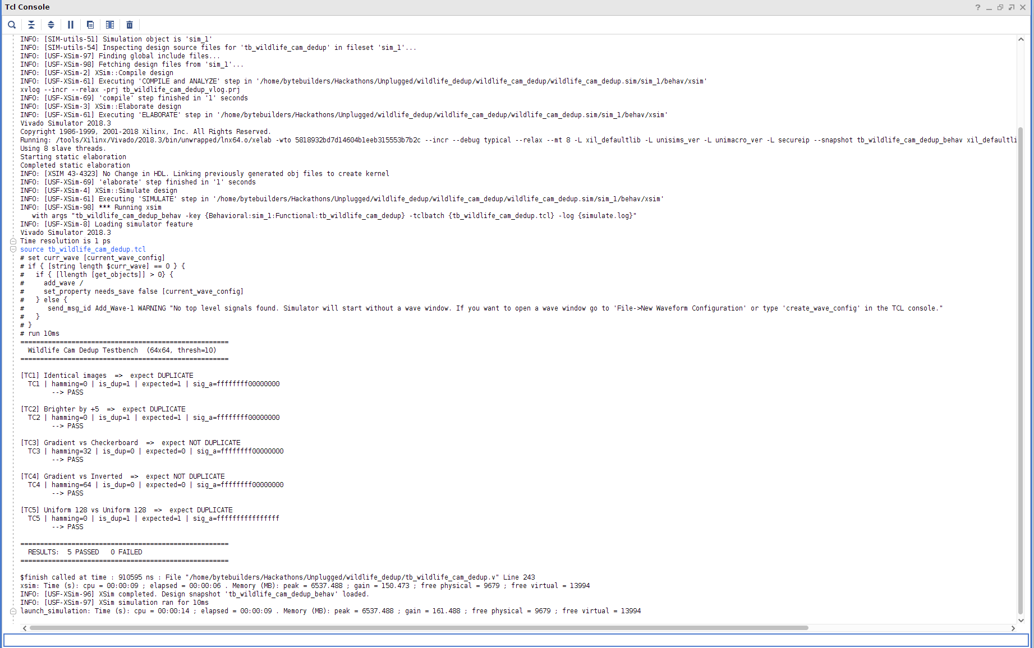

start_gui
open_project /home/bytebuilders/Hackathons/Unplugged/wildlife_dedup/wildlife_cam_dedup/wildlife_cam_dedup.xpr
open_project /home/bytebuilders/Hackathons/Unplugged/wildlife_dedup/wildlife_cam_dedup/wildlife_cam_dedup.xpr
Scanning sources...
Finished scanning sources
INFO: [IP_Flow 19-234] Refreshing IP repositories
INFO: [IP_Flow 19-1704] No user IP repositories specified
INFO: [IP_Flow 19-2313] Loaded Vivado IP repository '/tools/Xilinx/Vivado/2018.3/data/ip'.
open_project: Time (s): cpu = 00:00:10 ; elapsed = 00:00:06 . Memory (MB): peak = 6345.078 ; gain = 89.852 ; free physical = 9868 ; free virtual = 14108
update_compile_order -fileset sources_1
launch_simulation
INFO: [Vivado 12-5682] Launching behavioral simulation in '/home/bytebuilders/Hackathons/Unplugged/wildlife_dedup/wildlife_cam_dedup/wildlife_cam_dedup.sim/sim_1/behav/xsim'
INFO: [SIM-utils-51] Simulation object is 'sim_1'
INFO: [SIM-utils-54] Inspecting design source files for 'tb_wildlife_cam_dedup' in fileset 'sim_1'...
INFO: [USF-XSim-97] Finding global include files...
INFO: [USF-XSim-98] Fetching design files from 'sim_1'...
INFO: [USF-XSim-2] XSim::Compile design
INFO: [USF-XSim-61] Executing 'COMPILE and ANALYZE' step in '/home/bytebuilders/Hackathons/Unplugged/wildlife_dedup/wildlife_cam_dedup/wildlife_cam_dedup.sim/sim_1/behav/xsim'
xvlog --incr --relax -prj tb_wildlife_cam_dedup_vlog.prj
INFO: [USF-XSim-69] 'compile' step finished in '1' seconds
INFO: [USF-XSim-3] XSim::Elaborate design
INFO: [USF-XSim-61] Executing 'ELABORATE' step in '/home/bytebuilders/Hackathons/Unplugged/wildlife_dedup/wildlife_cam_dedup/wildlife_cam_dedup.sim/sim_1/behav/xsim'
Vivado Simulator 2018.3
Copyright 1986-1999, 2001-2018 Xilinx, Inc. All Rights Reserved.
Running: /tools/Xilinx/Vivado/2018.3/bin/unwrapped/lnx64.o/xelab -wto 5818932bd7d14604b1eeb315553b7b2c --incr --debug typical --relax --mt 8 -L xil_defaultlib -L unisims_ver -L unimacro_ver -L secureip --snapshot tb_wildlife_cam_dedup_behav xil_defaultlib.tb_wildlife_cam_dedup xil_defaultlib.glbl -log elaborate.log
Using 8 slave threads.
Starting static elaboration
Completed static elaboration
INFO: [XSIM 43-4323] No Change in HDL. Linking previously generated obj files to create kernel
INFO: [USF-XSim-69] 'elaborate' step finished in '1' seconds
INFO: [USF-XSim-4] XSim::Simulate design
INFO: [USF-XSim-61] Executing 'SIMULATE' step in '/home/bytebuilders/Hackathons/Unplugged/wildlife_dedup/wildlife_cam_dedup/wildlife_cam_dedup.sim/sim_1/behav/xsim'
INFO: [USF-XSim-98] *** Running xsim
with args "tb_wildlife_cam_dedup_behav -key {Behavioral:sim_1:Functional:tb_wildlife_cam_dedup} -tclbatch {tb_wildlife_cam_dedup.tcl} -log {simulate.log}"
INFO: [USF-XSim-8] Loading simulator feature
Vivado Simulator 2018.3
Time resolution is 1 ps
source tb_wildlife_cam_dedup.tcl
# set curr_wave [current_wave_config]
# if { [string length $curr_wave] == 0 } {
# if { [llength [get_objects]] > 0} {
# add_wave /
# set_property needs_save false [current_wave_config]
# } else {
# send_msg_id Add_Wave-1 WARNING "No top level signals found. Simulator will start without a wave window. If you want to open a wave window go to 'File->New Waveform Configuration' or type 'create_wave_config' in the TCL console."
# }
# }
# run 10ms
=====================================================
Wildlife Cam Dedup Testbench (64x64, thresh=10)
=====================================================

[TC1] Identical images => expect DUPLICATE
TC1 | hamming=0 | is_dup=1 | expected=1 | sig_a=ffffffff00000000
--> PASS

[TC2] Brighter by +5 => expect DUPLICATE
TC2 | hamming=0 | is_dup=1 | expected=1 | sig_a=ffffffff00000000
--> PASS

[TC3] Gradient vs Checkerboard => expect NOT DUPLICATE
TC3 | hamming=32 | is_dup=0 | expected=0 | sig_a=ffffffff00000000
--> PASS

[TC4] Gradient vs Inverted => expect NOT DUPLICATE
TC4 | hamming=64 | is_dup=0 | expected=0 | sig_a=ffffffff00000000
--> PASS

[TC5] Uniform 128 vs Uniform 128 => expect DUPLICATE
TC5 | hamming=0 | is_dup=1 | expected=1 | sig_a=ffffffffffffffff
--> PASS

=====================================================
RESULTS: 5 PASSED 0 FAILED
=====================================================

$finish called at time : 910595 ns : File "/home/bytebuilders/Hackathons/Unplugged/wildlife_dedup/tb_wildlife_cam_dedup.v" Line 243
xsim: Time (s): cpu = 00:00:09 ; elapsed = 00:00:06 . Memory (MB): peak = 6537.488 ; gain = 150.473 ; free physical = 9679 ; free virtual = 13994
INFO: [USF-XSim-96] XSim completed. Design snapshot 'tb_wildlife_cam_dedup_behav' loaded.
INFO: [USF-XSim-97] XSim simulation ran for 10ms
launch_simulation: Time (s): cpu = 00:00:14 ; elapsed = 00:00:09 . Memory (MB): peak = 6537.488 ; gain = 161.488 ; free physical = 9679 ; free virtual = 13994

